|  |  |
| --- | --- |
| **DATE** | 15 November 2022 |
| **TEAM ID** | PNT2022TMID26051 |
| **PROJECT NAME** | Smart crop protection system for agriculture |

**CREATE A DATABASE IN CLOUDANT DB**

**STEP 1:** Login to the IBM cloud account

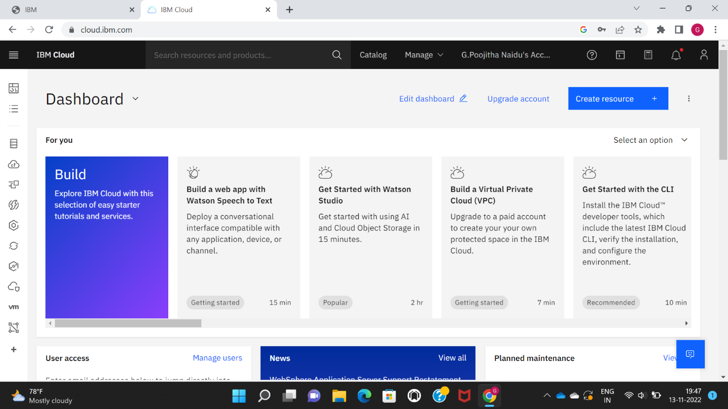

STEP 2: Go to Resource list and select a database

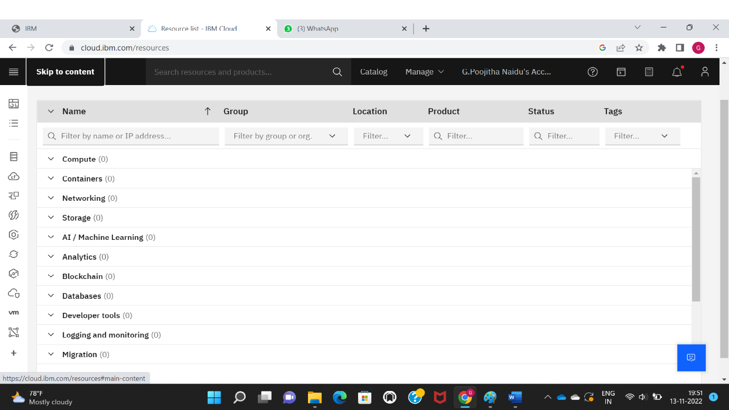

STEP 3: In the resource list select the active status cloudant service

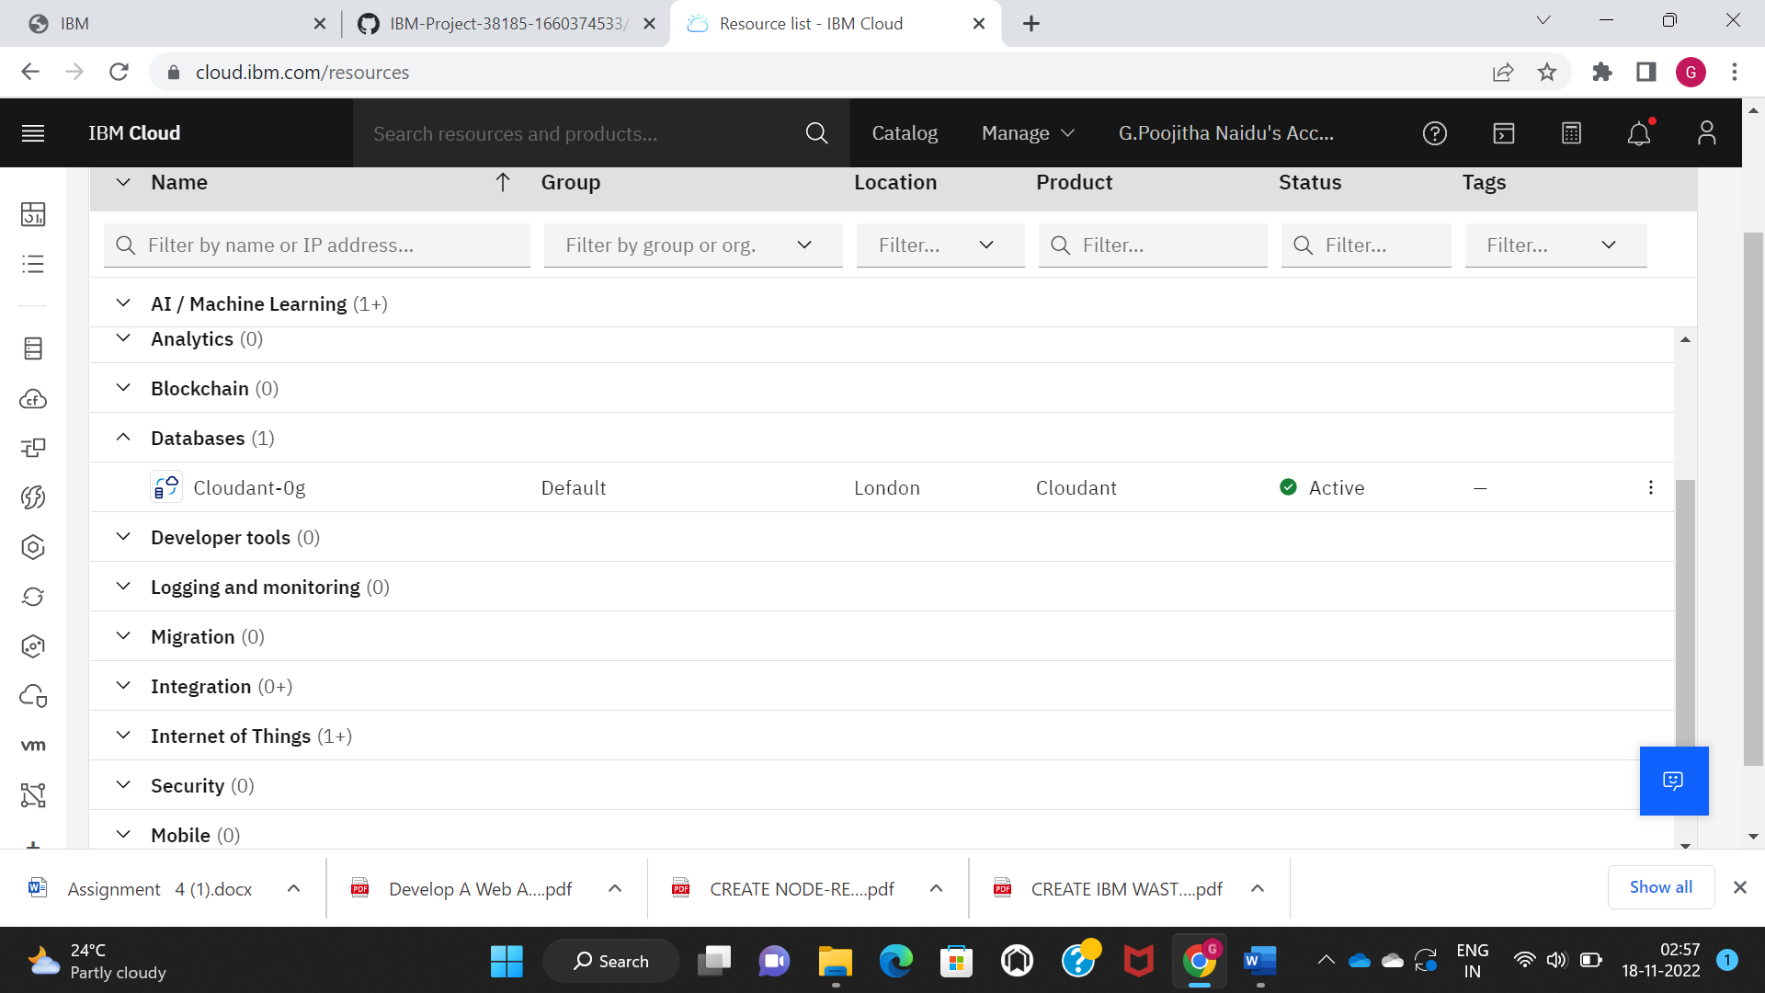

STEP 4: Click on the launch dashboard to get the overview of the Cloudant

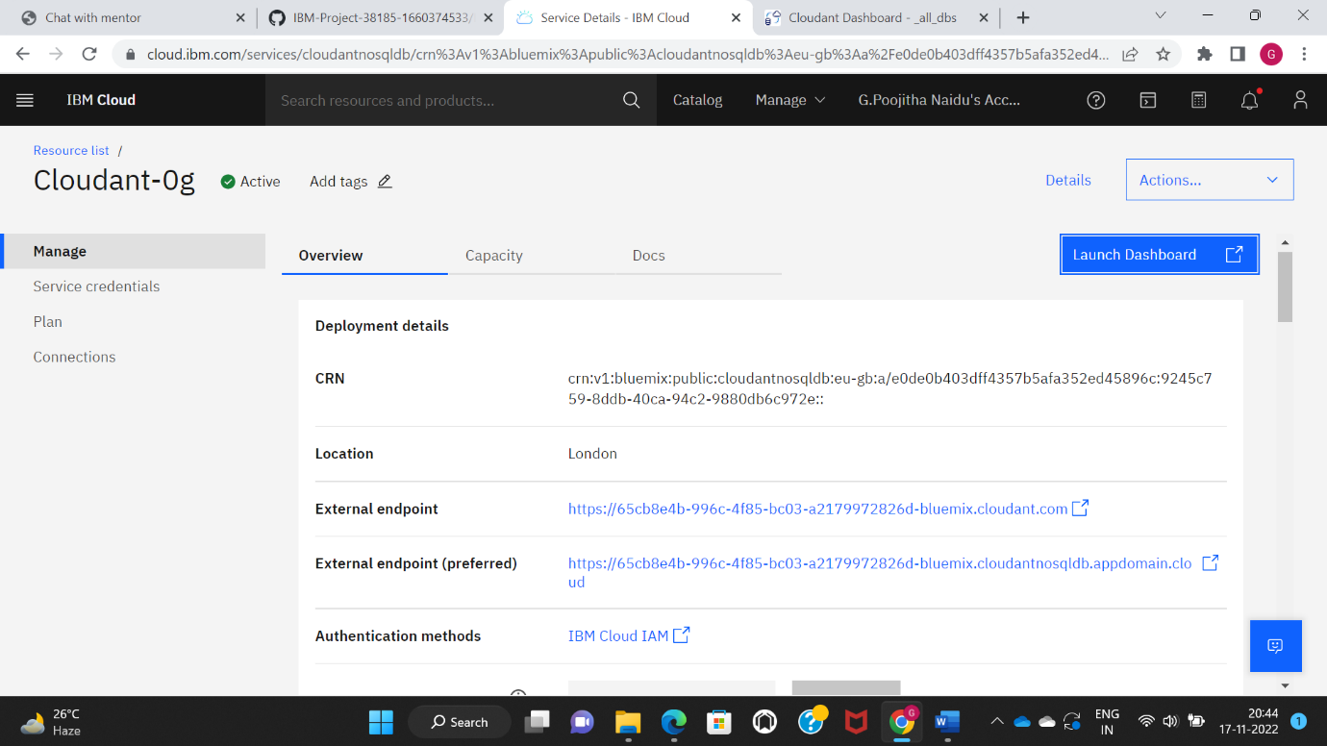

STEP 5: Now create a database as shown below

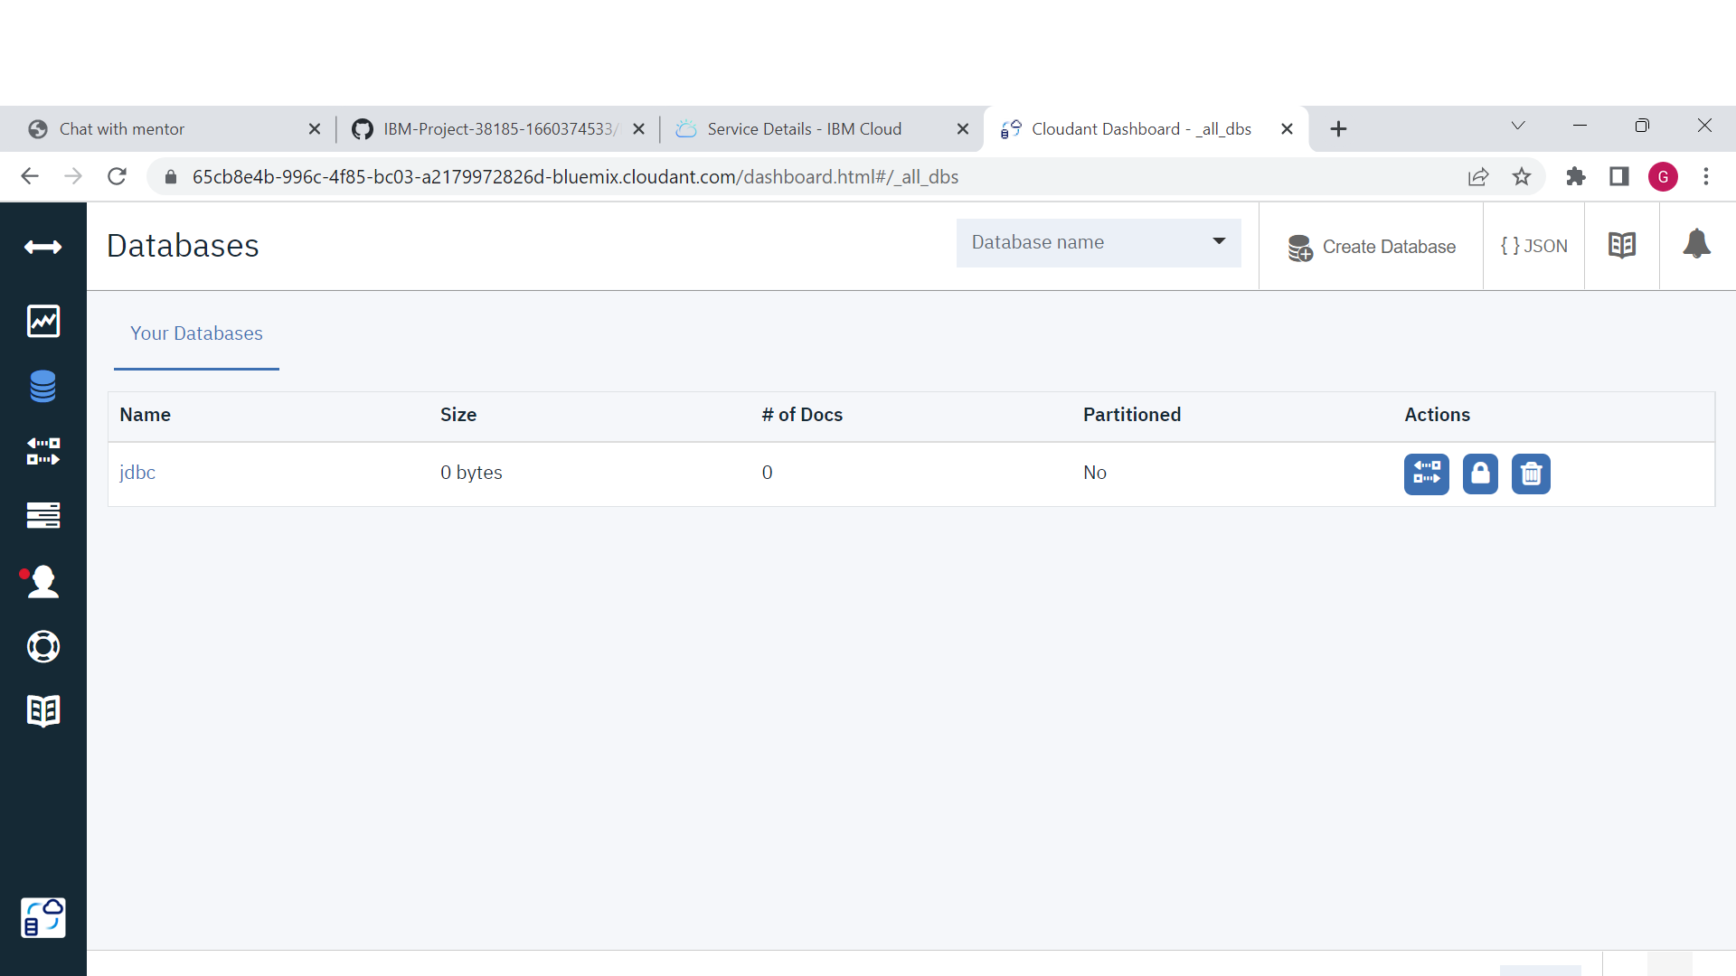

STEP 6: Now the database is created successfully

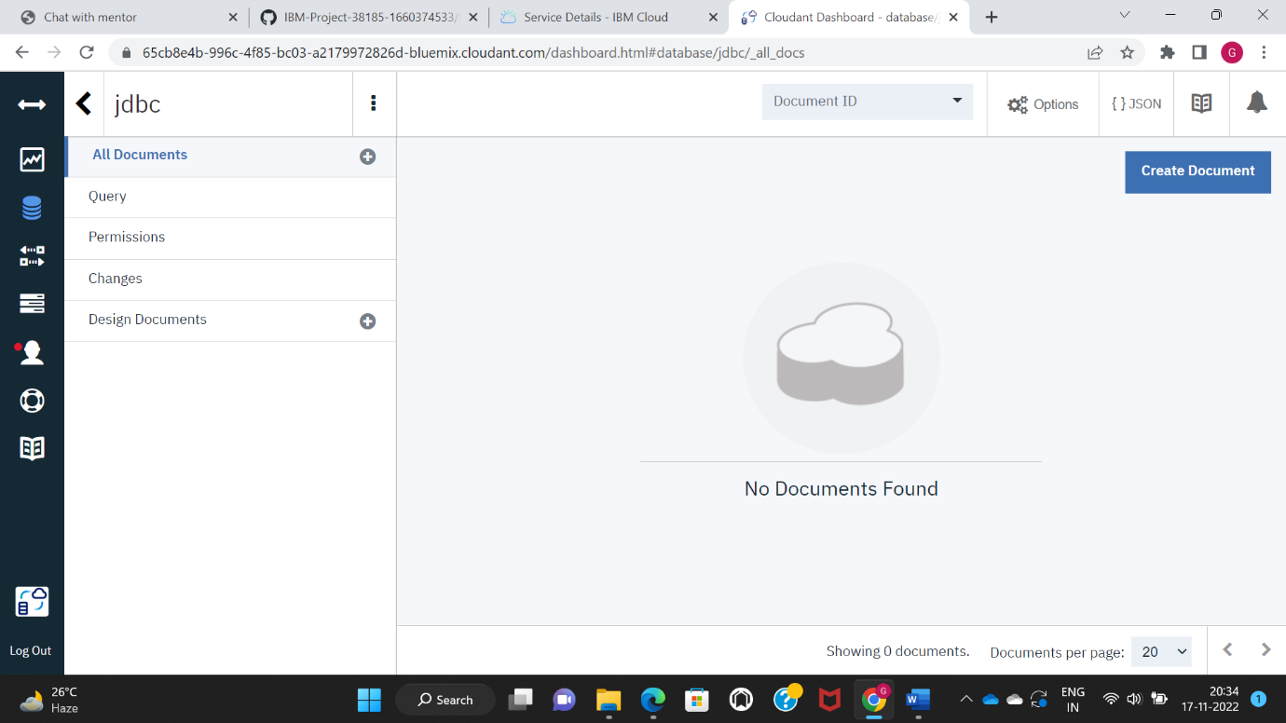

STEP 7: **Now to create document in this database click on create document like this you can create document for creating database to store the image URL**

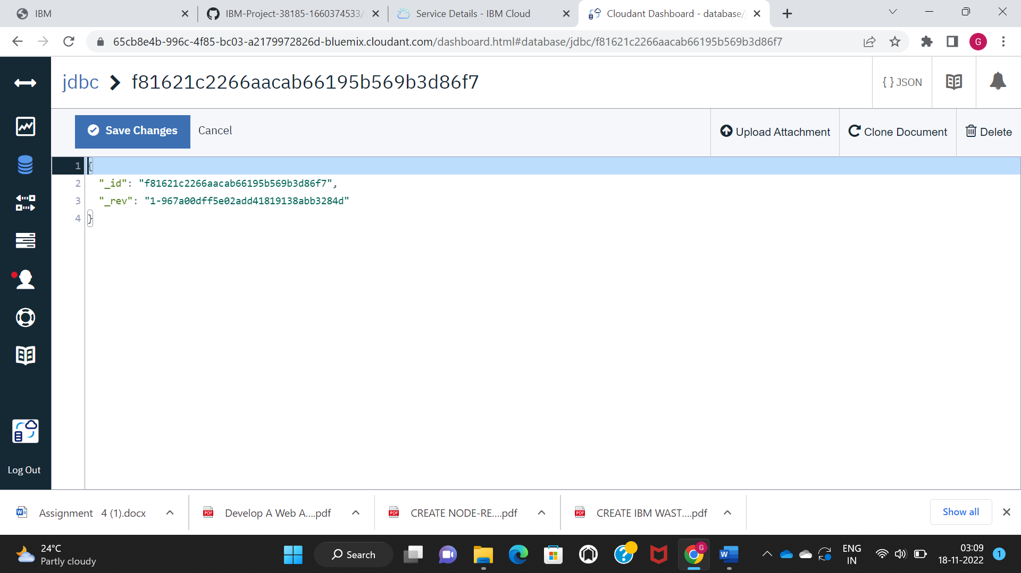

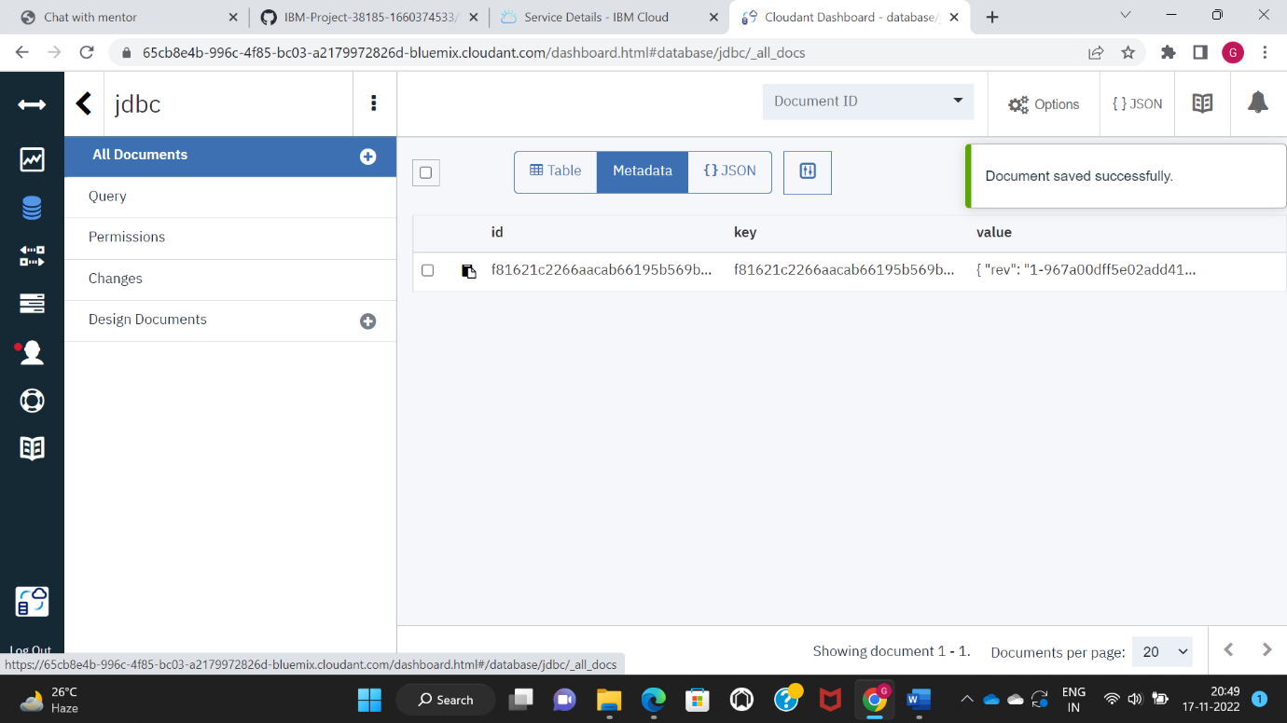

STEP 8: Therefore the document is created successfully